Working with

Issues

This course describes how to work with issues in Cortex®, including identifying key issue attributes, performing issue actions, and prioritizing issues by policies using starring rules or specific values.

Course Objectives
After completing this course, you should be able to:

- Work with Cortex issues in the Issues table
- Identify key issue attributes
- Perform issue actions
- Create issue starring rules to prioritize issues by policies
- Add specific values to featured issues fields and use them to prioritize issues

Lesson Topics
We recommend that you take the lessons in numerical order, but you can use the menu for quick access to any lesson at any time.
Click the lesson title buttons to go to each lesson. You can also navigate the course using the navigation arrows below or the menu bar at the top left of the screen.
Lesson 1: Issue Objects, Attributes, and Actions
Lesson 2: Issue Starring Rules
Lesson 3: Featured Issue Fields

Issue Objects,

Attributes, and Actions

This lesson describes issues, key issue attributes, issue sources, and various actions you can perform on issues.

Common Issue Objects
By analyzing an issue, you can better understand the cause of what happened in full context to validate whether an issue requires additional action.

Common to All License Types
Common issue-related objects that are available for all license types:

Issue
An issue is a notification type of data to report a suspicious activity or an event.

Case
A case is a container object to group-related issues as well as other attack-related data.

Log
A log is any data collection of name-value pairs; values may not be atomic but multiple values.

Available with in XDR Pro Endpoints
Issue-related objects that are available with XDR Pro endpoints

Stitched Issues
A stitched issue is an issue enhanced by Cortex, which is automatically correlated with logs to provide better attack visibility.

Causality Group Owner (CGO)
CGO is the process identified as a root cause of an attack; the initiator.

Causality View
This view is the name of a management console page specialized for causality analysis of issues, in particular stitched issues.

Working with Issues
The management console displays issues in the Issues table. You can access the Issues table by navigating to Cases and Issues > Issues. Alternatively, you can access the page by entering the URL path: /issues.
By default, the Issues table displays the issue received over the last 30 days. You can click an issue to open its summary pane. Click the image to enlarge it.
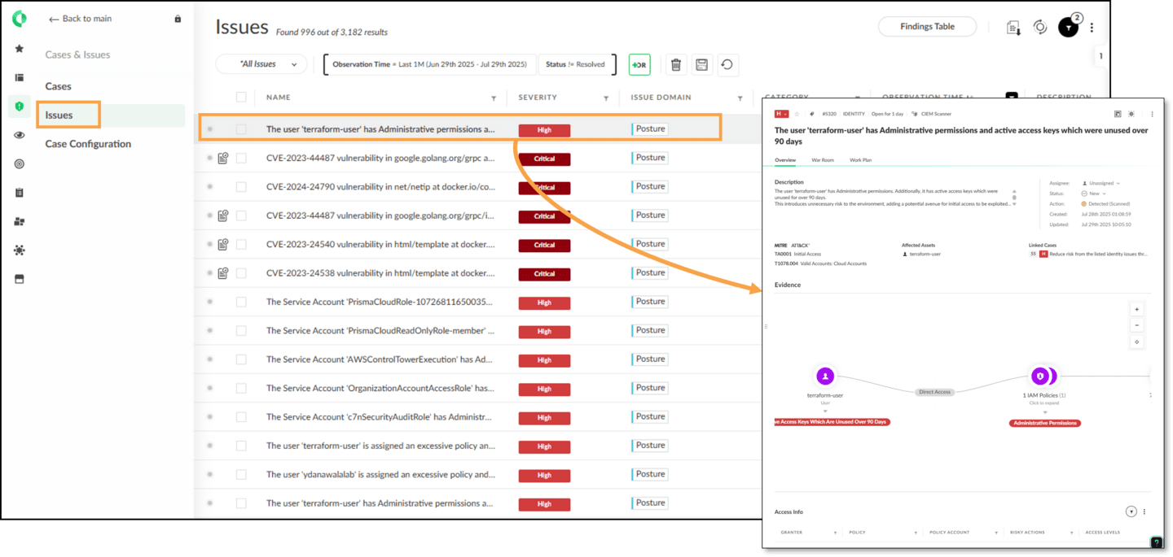

Key Issue Attributes
The Issues table contains the following key attributes.
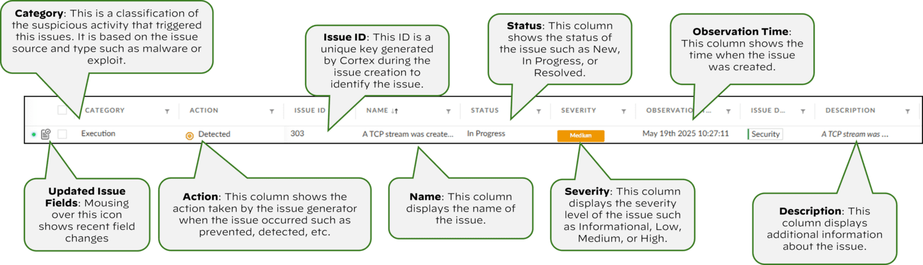

External ID Attribute
An issue's External ID is generated by the issues source; therefore, this attribute is external to the Cortex instance. The External ID column is hidden by default; you can enable this column from the Layout Manager.
In case the source is the Cortex XDR agent, this ID is known as the prevention ID. The image shows the Prevention folder on the endpoint, which contains a subfolder that has the same name as the External ID displayed in the Issues table. The Cortex XDR agent created this subfolder when it generated the issue.

Click the image to enlarge it.
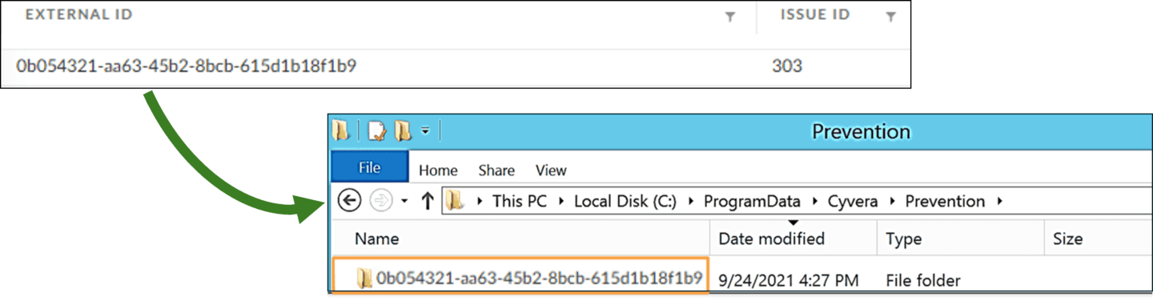

Issue Attributes in JSON
You can get more in-depth, attribute-specific information about an issue by reviewing its attributes values.
To display the issue's attribute values, press Alt and right-click the issue in the Issues table to open the shortcut menu. Click Debug issue to open a dialog that displays issue attributes in JSON format.
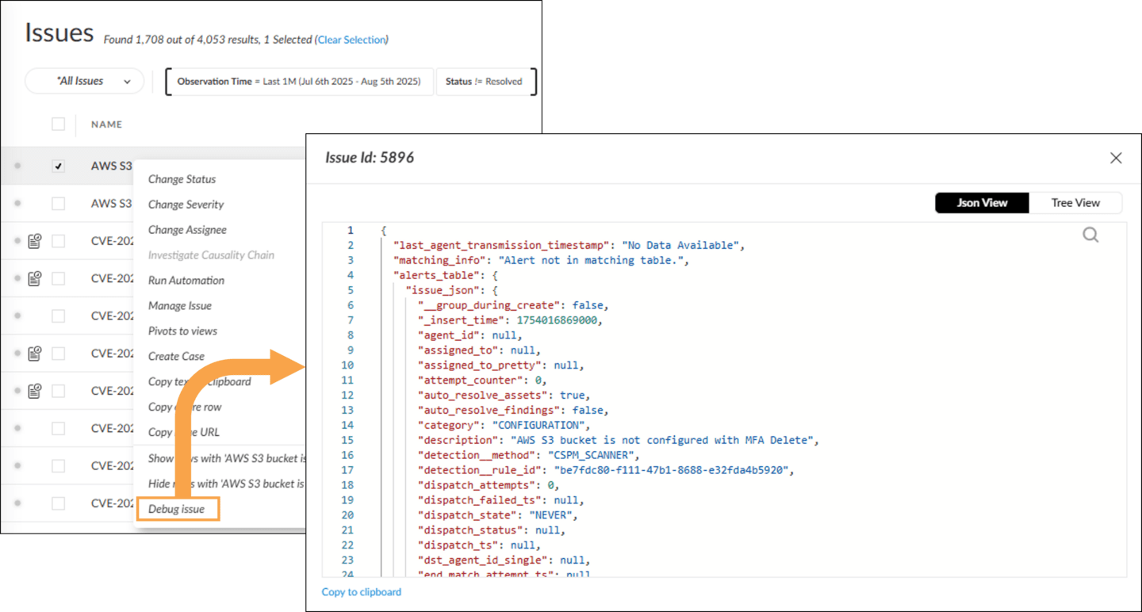

Actions on Issues
An issue's shortcut menu displays the applicable actions whose availability vary depending on the source and category of the issue and whether the issue was stitched with the endpoint data.
Click the arrows for more information about some of the actions available for a behavioral threat issue.

Investigate Causality Chain

- From the Investigate Causality Chain menu, you have the option to
- open the issue in Causality View or Timeline View in a new browser tab or in the same tab.
- 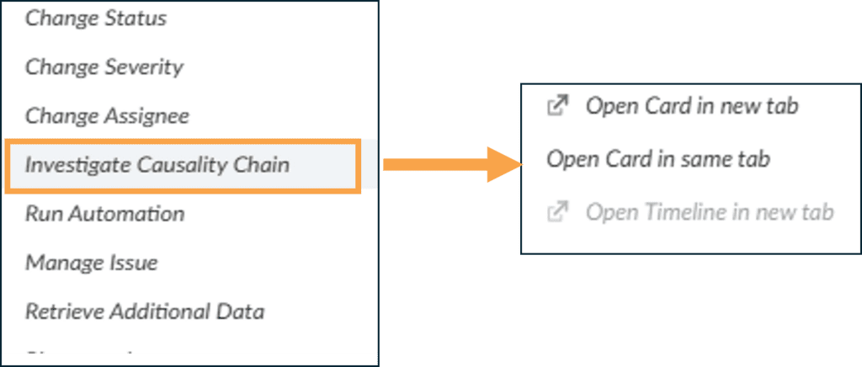

Manage Issue

- Under Manage Issue, you can select Create exclusion rule to put the rule that caused the Cortex XDR agent to trigger the issue into silent mode so it does not fire issues. You can use Exclude Issue to exclude the issue from the investigation.
- 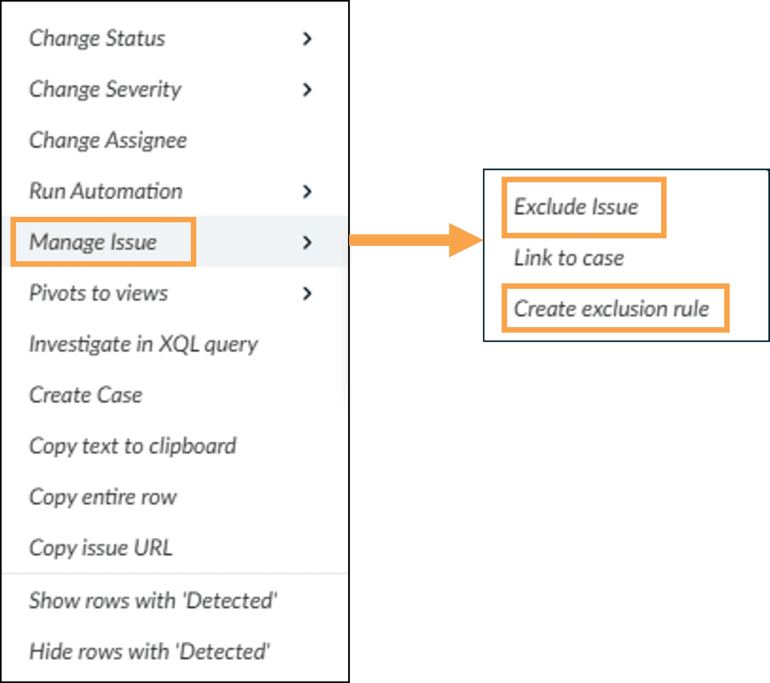

Retrieve Additional Data

- Under the Retrieve Additional Data option, you have two options:
  - Retrieve issue data: This option retrieves additional data about the activity such as process memory dump from the endpoint.
  - Retrieve related files: This option initiates retrieval of the attack-related files, mainly the executables.
- 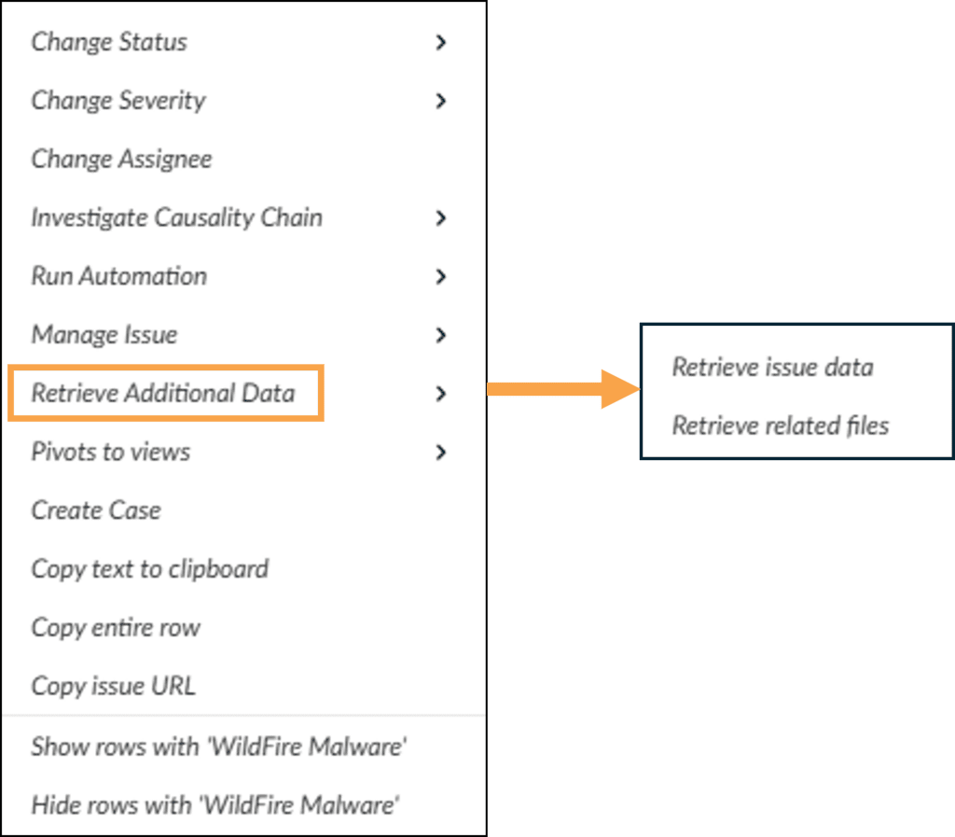

Pivots to Views

- Under Pivots to views, you can select Investigate option to view and manage the issue in more detail or Open Host Risk View to view additional host risk information.
- 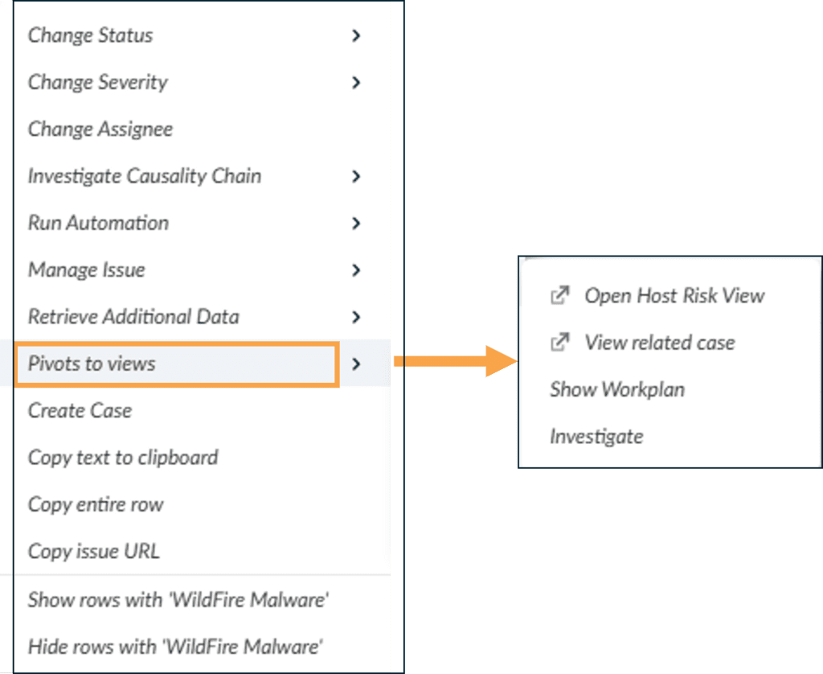

Issue Starring

Rules

This lesson describes issue starring rules that are used to prioritize issues.

Starred Issues
An issue starring is a rule to star and prioritize an issue. A starred issue also prioritizes their hosting cases.
You can add a starring policy in Cases & Issues > Case Configuration > Starred Issues. As rule criteria, select some actions using filters.
Note: An issue exclusions rule takes precedence over an issue starring rule if the same issue matches to both.
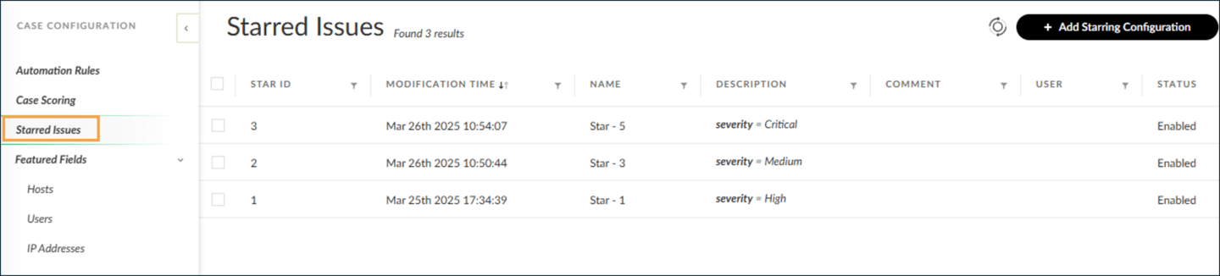

Starred Issues in Issues Table
In the Issues table, you can sort or filter by Starred. You can identify starred issues by the star icon in the Name column.

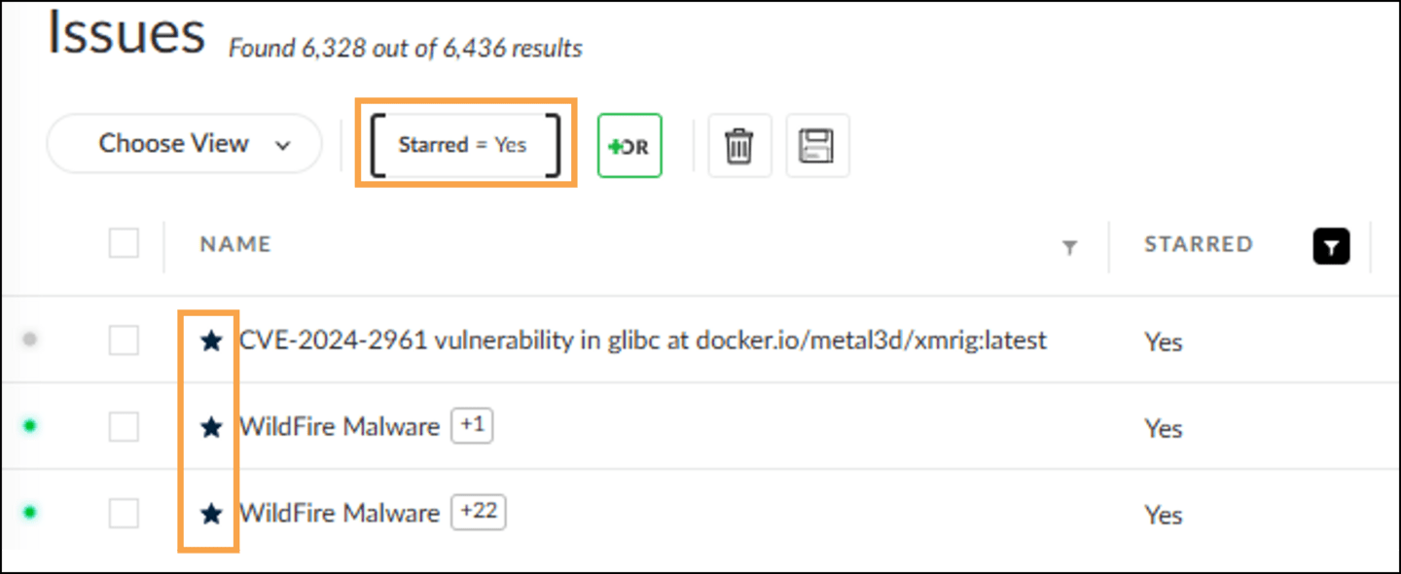

Creating New Issue Starring Rules
To create a new issue starring, navigate to Cases & Issues > Case Configuration > Starred Issues . Click +
Add Starring Configuration and define policy rule criteria using issue attributes.
On the Create New Issue Starring Configuration window, you can use the filter button to select the attributes and specify the values. Alternatively, you can select an existing issue in the Issues table, open the shortcut menu, and perform the Add issues with or Add issues without action.
Note: The Configuration Name (also known as rule name) is auto-filled.
Click the image to enlarge it.
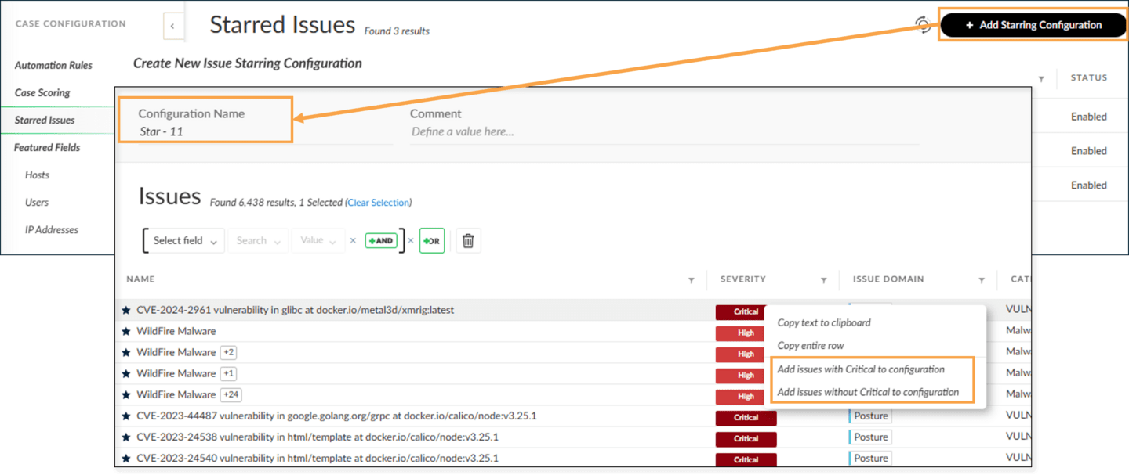

Featured

Issue Fields

This lesson describes the featured issue fields available in Cortex and how to add, filter, and alter issue and case attributes.

Featured Issue Fields Overview
You use the featured issue fields to easily locate and prioritize issues with specific values. The featured issue fields are Host, User, and IP Address.

Functionality

The featured issue fields provide similar functionality as filtering in the Issues table. Consider how challenging creating filter criteria for a list of 100 hostnames would be. You can instead use the featured issue fields to prioritize issues based on hostnames.

How to Use

To benefit from this feature, you first add new featured field values to any of the featured issue fields, and then you sort or filter the Issue table on those provided issue fields.
For example, you can add a list of hostnames as the featured issue field values of the Host type. Then, to prioritize or better highlight issues that contain any one of the values you added, you use the provided issue fields to sort or filter.

Prioritize Issues Containing Featured Values
After you add specific values to featured fields, prioritize issues containing featured field values in the Issues table.
Issues containing featured fields are presented in the Issues table as follows. Click the images to enlarge them.

Issue Name
The Issue Name indicates issues containing a featured value with a red flag.
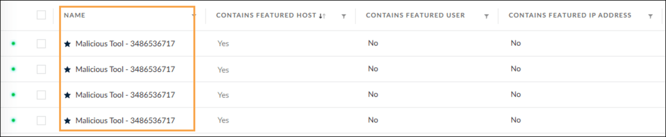

Contains Featured Host, Contains Featured User, and Contains Featured IP Address
These "Contains Featured" fields display whether the issue has a hostname, a username, or an IP address added respectively. To get more details, such as which featured fields have matching values, you can use the Yes- or No-valued in these fields to sort or set filters on.
Note: The Featured Active Directory values are displayed in the Contains Featured User or Contains Featured Host fields accordingly.
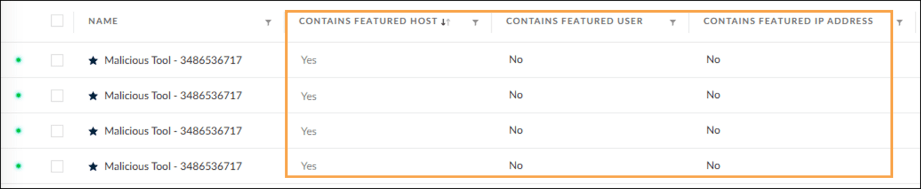

Add New Featured Field Values
To add new featured field values, go to Cases & Issues > Case Configuration > Featured Fields and click one of the available featured value options: Hosts, Users, and IP Addresses. Each option has its own page, which opens on the right.
In this example, the steps to add a featured host value are as follows:
- Click Hosts on the left navigation.
- On the Hosts page, click + Add featured Hosts.
- Select Create New or Upload from File. To add more values, click Add.
Click the image to enlarge it.
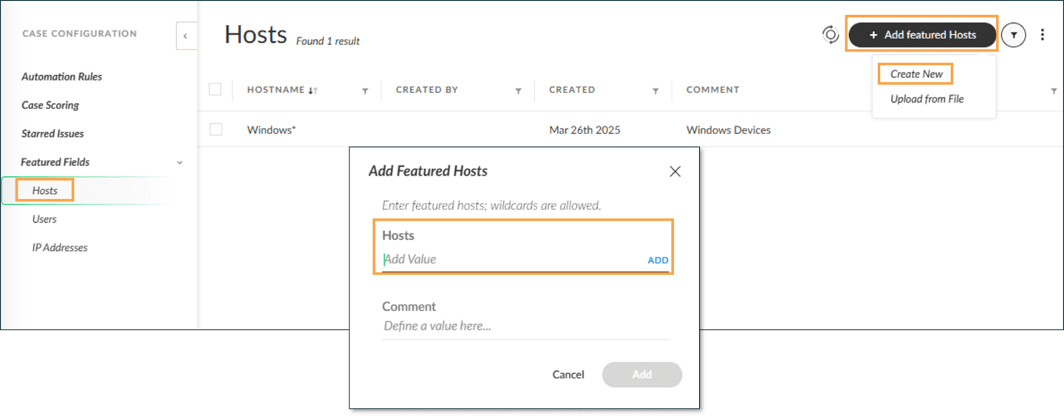

Filtering Cases and Issues with Tags
You can filter cases or issues using Tags. Tags are metadata labels used to organize, categorize, and search cases, issues, and endpoints.

Cases and Issues > Cases
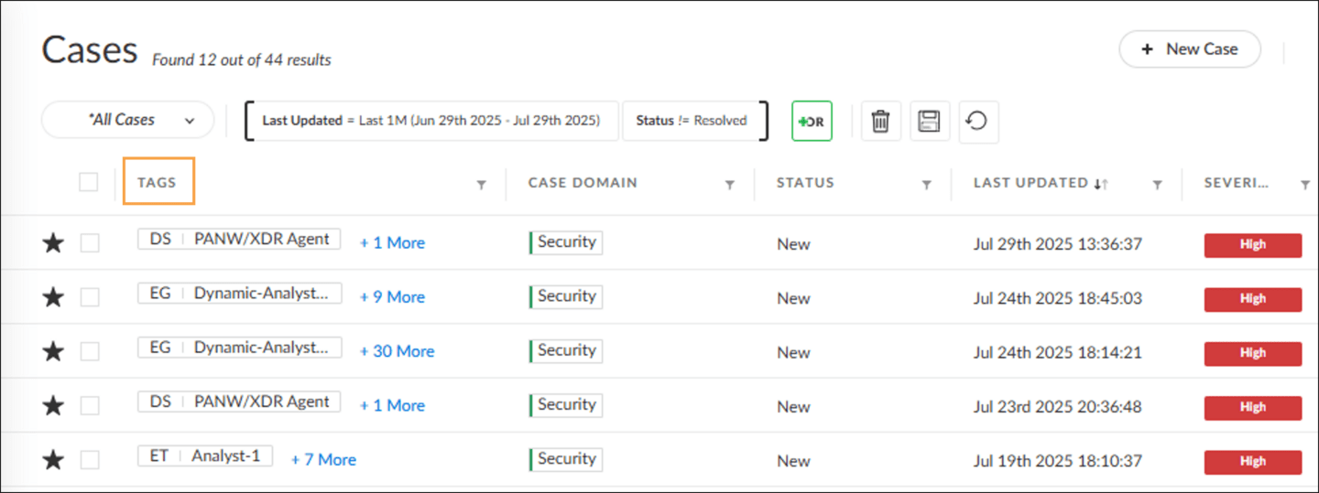

Cases and Issues > Issues
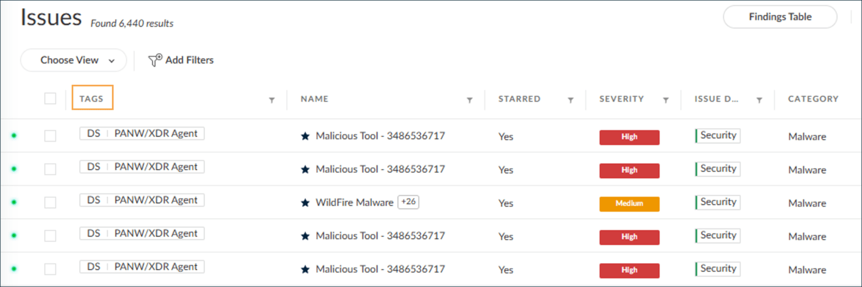

Manually Changing Issue and Case Status and Severity
You can change the status and severity of an issue or incident by right-clicking on an issue or case and selecting Change Status or Change Severity.
Click the images to enlarge them.

Changing Status
From the Change Status menu, you can set the status for an issue or case to New, In Progress, or Resolved.
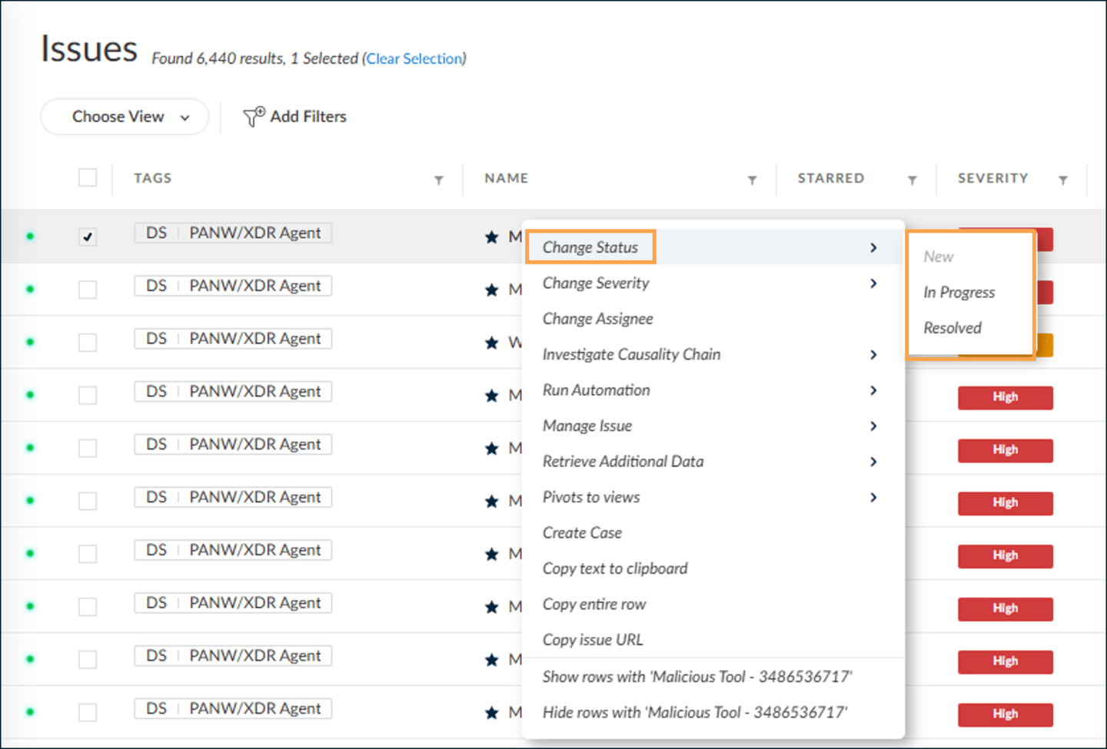

Changing Severity
Instead of right-clicking to change the case's severity, you can click the severity icon to the left of the star and select a new severity from the drop-down menu.
This example shows that the severity of this case has been downgraded to Medium from High.
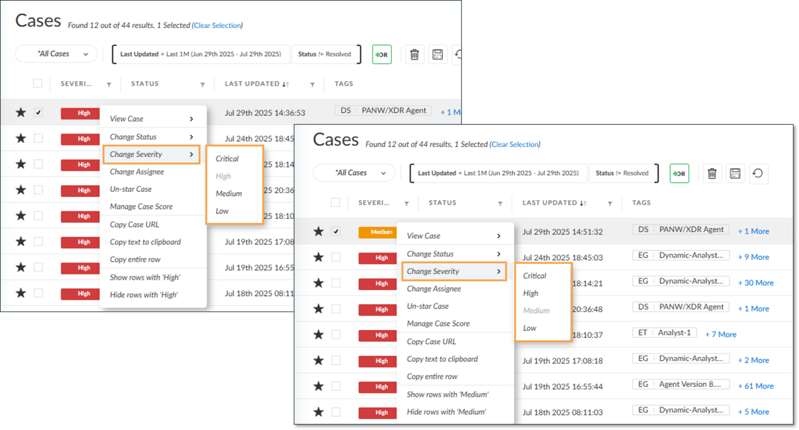

Course Summary
Now that you've completed this course, you should be able to:

- Work with Cortex issues in the Issues table
- Identify key issue attributes
- Perform issue actions
- Create issue starring rules to prioritize issues by policies
- Add specific values to featured issues fields and use them to prioritize issues

